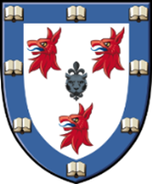

Formal Hall Menu Tuesday 13th June

Cream cheese filled pepper, quinoa, chargrilled courgettes, kalamata olives, rocket, micro basil

Herb crusted supreme of hake with roasted new potatoes and red peppers, fine beans, pea and watercress puree, dill oil
Ratatouille filled baby aubergine with roasted new potatoes and red peppers, fine beans, pea and watercress puree, dill oil

Mango cheesecake, mango sorbet, shortbread crumb, micro mint, mango puree

