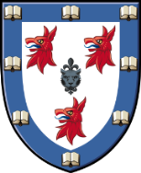
Dinner counter early closing
Tuesday 6th June & Friday 9th June

Evening dinner counter will close at 6.30pm on Tuesday
6th & Friday 9th June to allow for Formal hall set up

We apologise for any inconvenience

