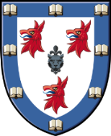
Dinner counter early closing
Tuesday 13th June & Wednesday 14th June

Evening dinner counter will close at 6.30pm on Tuesday
13th & Wednesday 14th June to allow for Formal hall set up

We apologise for any inconvenience

