**A selection from the Formal Hall Menus This Term**

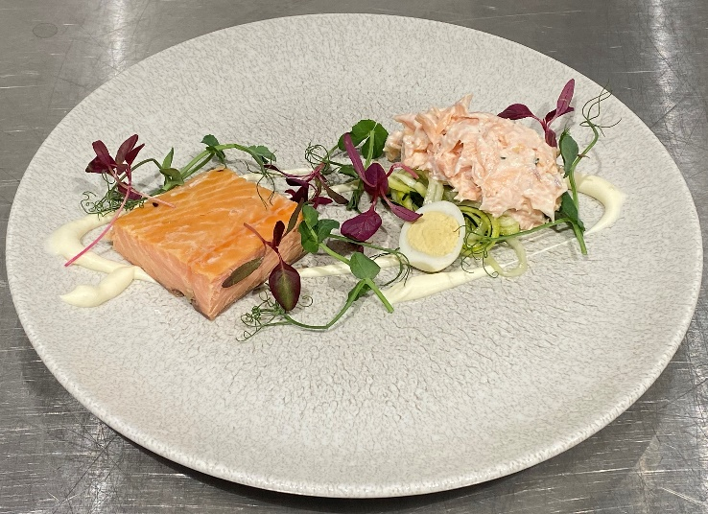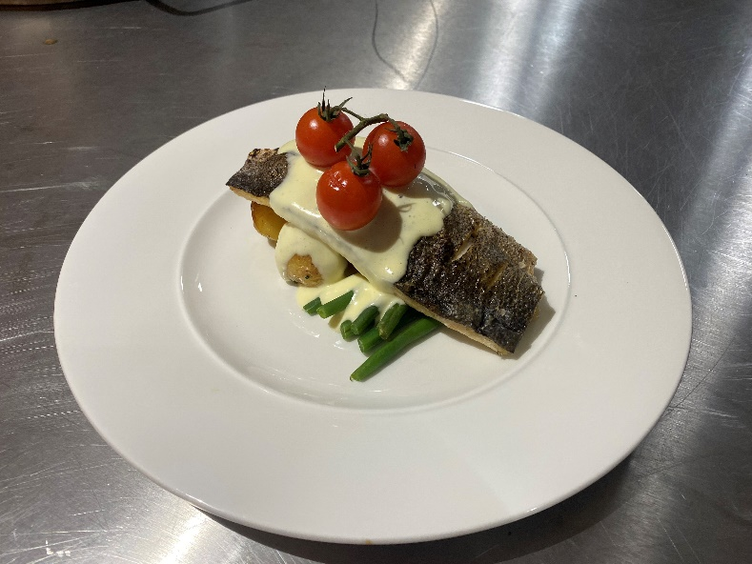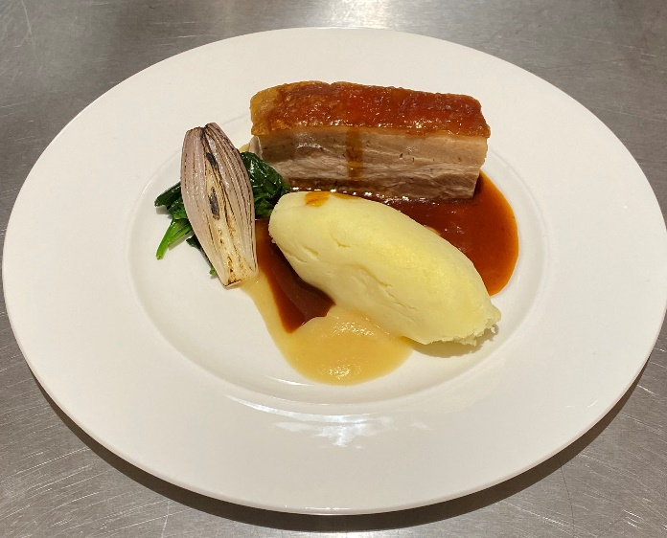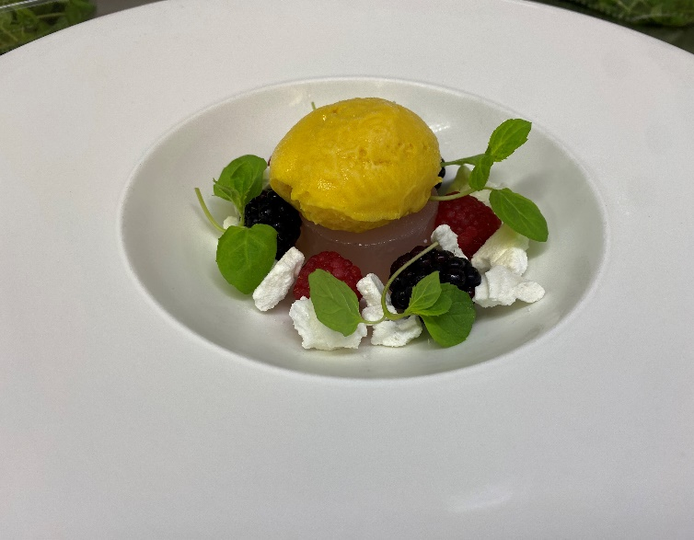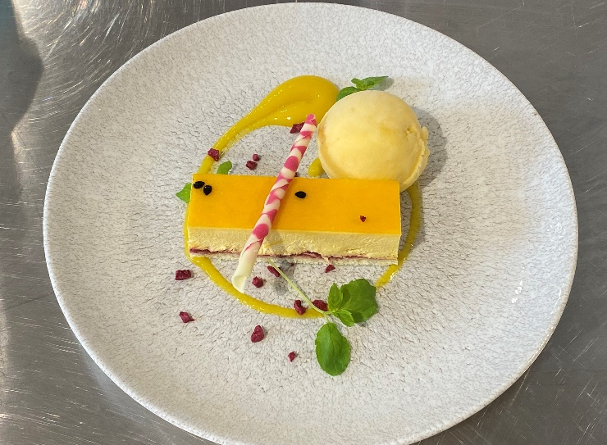

**Hot smoked salmon, horseradish creme & fresh pickled courgette**

**Seabass with roasted new potatoes, fine green beans, vine cherry tomatoes & white wine sauce**

**Gin and tonic jelly mango sorbet**

**Pork belly with burnt apple and cognac puree, parmesan mash, spinach & charred shallot**

**Passion fruit and mango gel**