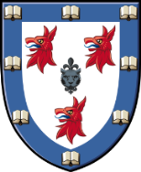
Dinner Counter Service
Tuesday 31st January & Thursday 2nd February

On Tuesday 31st January & Thursday 2nd February the counter will be open 5.30pm – 6.30pm to allow for our Formal Hall Dinners

We apologise for any inconvenience

