Never leave cooking unattended

Never remove burning items from the Gyp Room / Kitchen
Always keep Gyp Room / Kitchen door closed

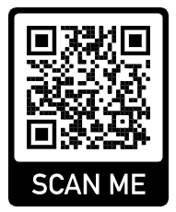

Click on this QR Code to see a short video on the
Correct Use of a Fire Blanket

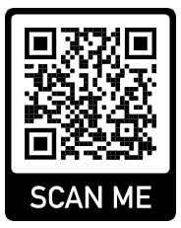
Cooking for Friends?
Click on this QR code to see a short video explaining the Most Common Food Allergens

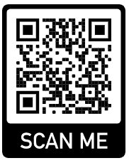
Click on this QR Code to see a short video on how to recognise the Symptoms of an Anaphylactic Shock

